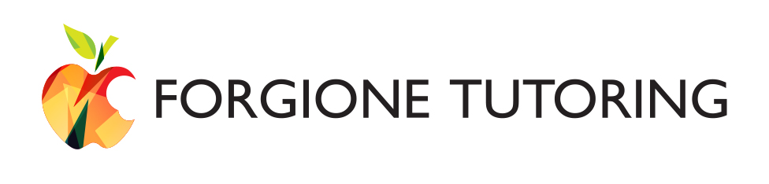
3820 Merton Dr. Suite 215
Raleigh, NC 27615
(919) 800-8663
heather@forgionetutoring.com
www.forgionetutoring.com
3820 Merton Dr. Suite 215
Raleigh, NC 27615
(919) 800-8663
heather@forgionetutoring.com
www.forgionetutoring.com
Photo/Video Consent Form

Forgione Tutoring will occasionally use social and other media to highlight the positive experiences students have at Forgione Tutoring. Forgione Tutoring will never release any student details, such as names, scores or special accommodations, without expressed written permission from the student’s parent or guardian. Student images may be published or displayed in printed media (such as brochures or newsletters), videos, and on Forgione Tutoring’s website, Facebook, Twitter, and Instagram pages.

Please complete this form and have your child return it to one of our Directors or his or her tutor.

Select one of two options for granting or denying consent:

- I deny permission for any use of my child’s image for display or publication. (Select this option if you do not want your child’s image to be used on Forgione Tutoring’s website, in our publications, or on our social media pages.)

- I hereby grant Forgione Tutoring the right to take, exhibit, and make use of photographs or video taken of my child to be used in and/or for legally promotional materials including, but not limited to, newsletters, flyers, posters, brochures, Forgione website, social networking sites, without payment or any other consideration. This authorization extends to all languages, media, formats and markets now known or hereafter devised. This authorization shall continue indefinitely, unless I otherwise revoke said authorization in writing. I understand and agree that these materials shall become the property of Forgione Tutoring and will not be returned. (A student will not be identified by name.)

If you choose to revoke or change your selection, please inform Heather Forgione in writing at heather@forgionetutoring.com.

Name of Parent/Guardian (Print) ____________________________________________
(if student is under 18 years of age)

Parent/Guardian Signature: _________________________________________________

Student Name: ___________________________________________________________

Date: ________________________________

